**CN Lab 8 Report**

190030043- T Satwik

The following sections showcase the effect of each of the parameters on CW. I have plotted graphs for each of the given set of parameters and kept the images one below the other so that we can compare them.

1. **Effect of varying Ki on CW.**

I have used 4 values for Ki ={1, 2, 3, 4}. Other parameters are Km=1, Kn=1, Kf=0.2, Ps=0.01 in all cases. Plots obtained for each of this set of parameters are plotted together in this figure.

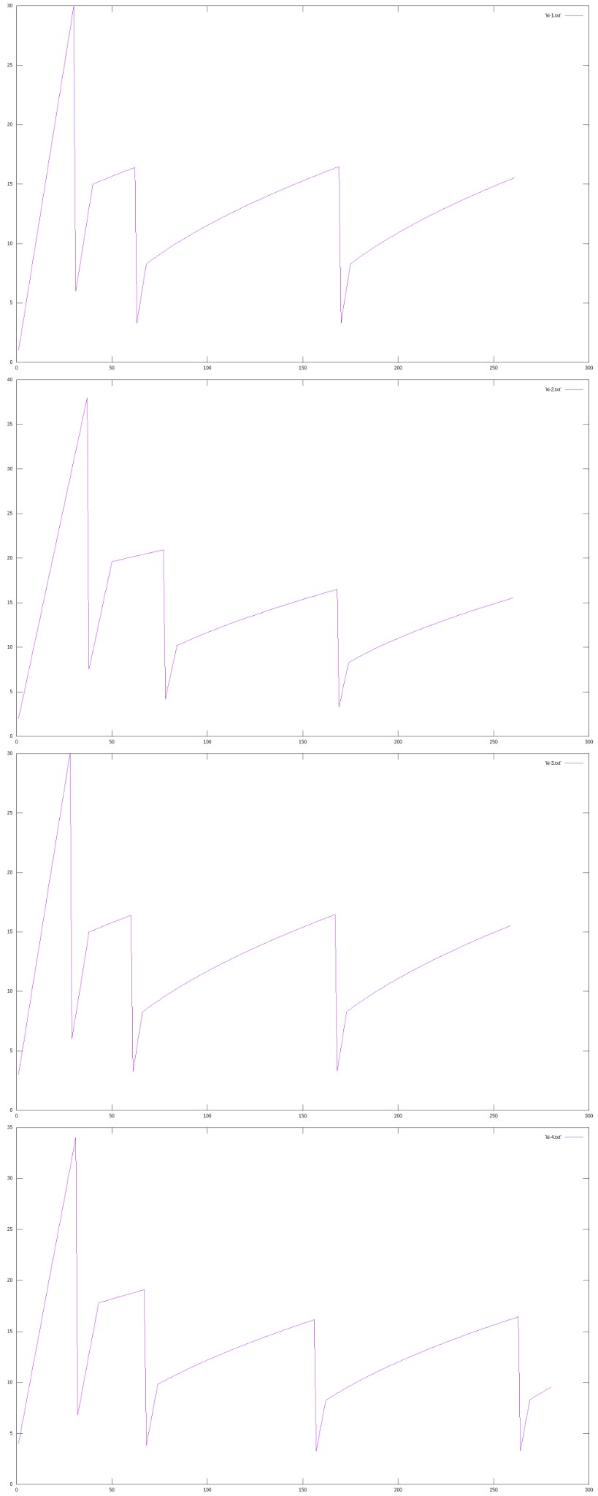

As we already know that, Ki only sets the initial value of CW,

CW=Ki*MSS

Hence the plots in all the cases are almost similar, however the initial CW value is different in each of the cases.

1. **Effect of varying Km on CW.**

I have used 3 values for Km ={1, 1.5, 2}. Other parameters are Ki=1, Kn=1, Kf=0.2, Ps=0.01 in all cases. Plots obtained for each of this set of parameters are plotted together in this figure.

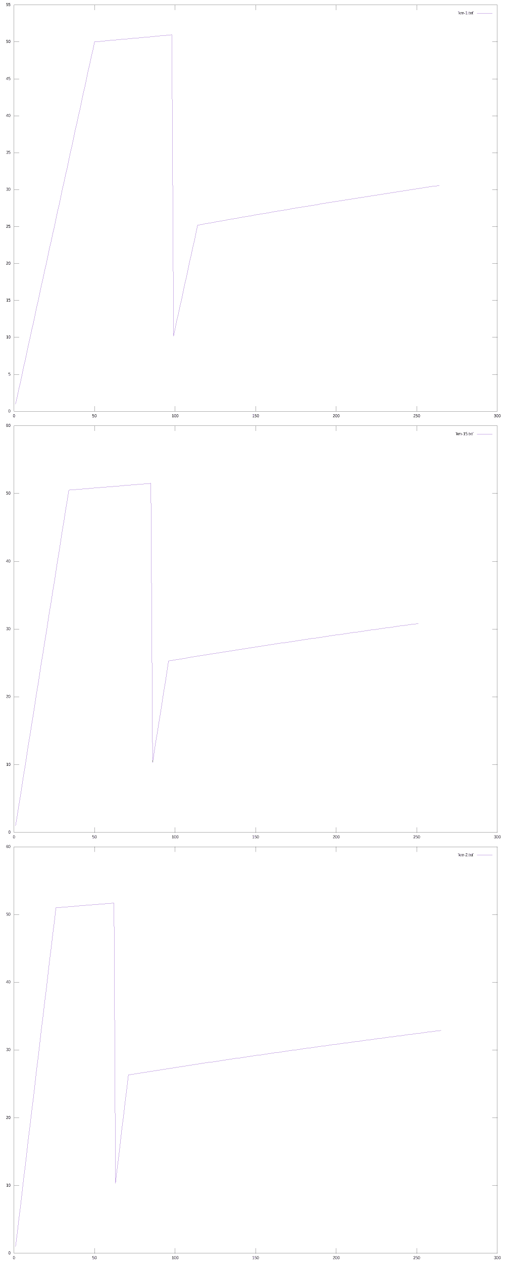

As we already know that, Km influences the exponential growth phase.

As we can see from the plots, the slope of the lines in the slow start/exponential phase is increasing, as km value is increasing. It takes less number of iterations to get to the threshold value in case 3 than in case 1, hence slope is increasing.

1. **Effect of varying Kn on CW.**

I have used 4 values for Km ={0.5, 1, 1.5, 2}. Other parameters are Ki=1, Km=1, Kf=0.2, Ps=0.01 in all cases. Plots obtained for each of this set of parameters are plotted together in this figure.

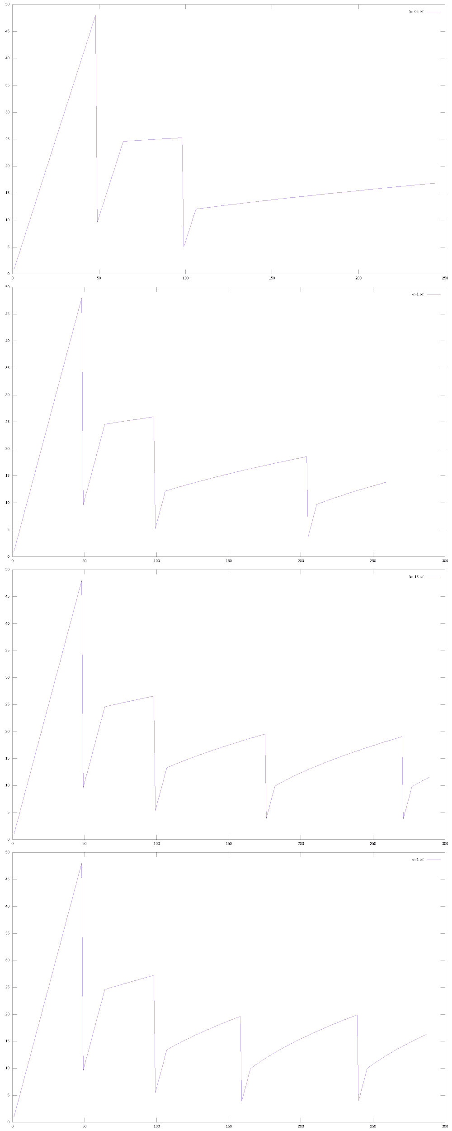

As we already know that, Kn influences the linear growth phase.

CW = min(CW + Kn ∗ MSS ∗ MSS/CW, RWS)

As we can see from the plots, the slope of the lines in the linear growth/congestion avoidance phase is increasing, as kn value is increasing. The linear growth phase lines become more steep as kn increases. And it is more steep in case 4 than in case 1, hence slope is increasing.

1. **Effect of varying Kf on CW.**

I have used 3 values for Kf ={0.1, 0.2, 0.3}. Other parameters are Ki=1, Km=1, Kn=1, Ps=0.01 in all cases. Plots obtained for each of this set of parameters are plotted together in this figure.

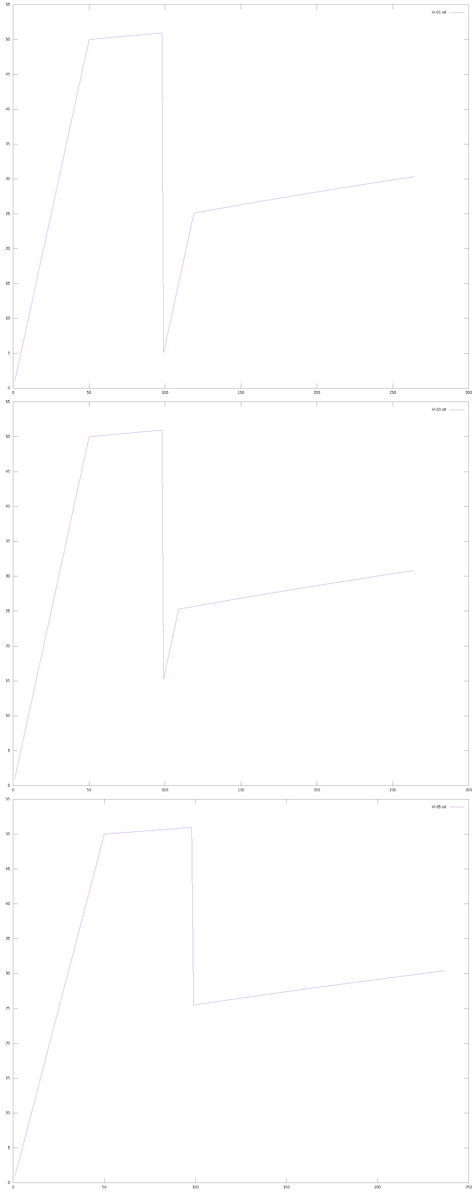

As we already know that, Kn influences the multiplicative decrease phase.

CW = max(1, Kf ∗ CW)

As we can see from the plots, the min value to which the CW size drops after congestion is detected is increasing. As kf increases the fall/dip in the graph is also decreasing and the minimum value is increasing. The minimum value in case 3 is greater than the minimum value in case 1, hence the the minimum value is increasing.

1. **Effect of varying Ps on CW.**

I have used 3 values for Kf ={0.01, 0.05, 0.10}. Other parameters are Ki=1, Km=1, Kn=1, Kf=0.2 in all cases. Plots obtained for each of this set of parameters are plotted together in this figure.

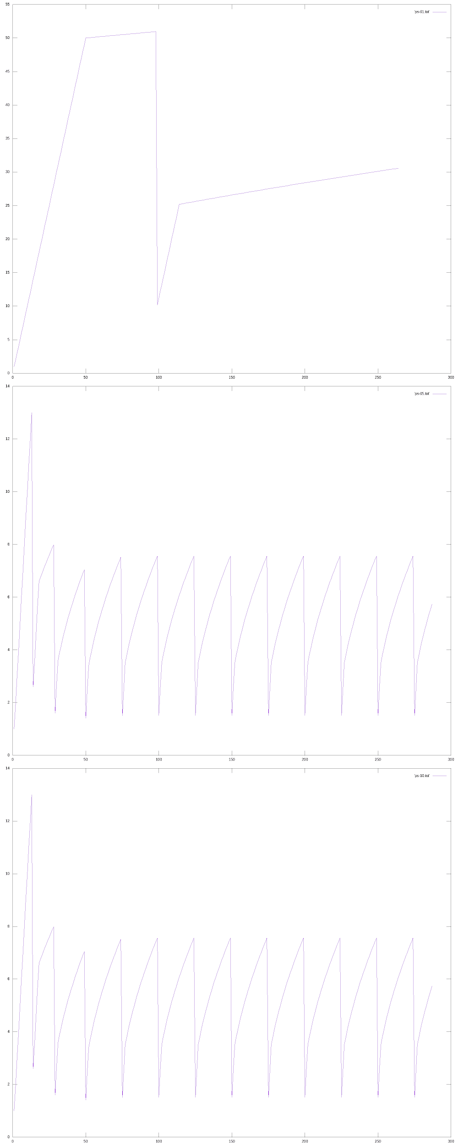

As we already know that, Ps influences the probability of the packet loss.

Ps=probability that the packet is lost

As we can see from the plots, the multiplicative decrease phases or dips in the graph are more in case 3 than in case 1. The number of dips in the graph increase as Ps values in increased.